**Project Design Phase-II**

**Data Flow Diagram & User Stories**

|  |  |
| --- | --- |
| Date | 28 June 2025 |
| Team ID | LTVIP2025TMID60659 |
| Project Name | Sustainable Smart City Assistant Using IBM Granite LLM |
| Maximum Marks | 4 Marks |

**Data Flow Diagrams:**

A **Data Flow Diagram (DFD)** is a simple visual tool that shows how data moves through a system. It helps us understand where the data comes from, how it is used or changed, where it goes, and where it is stored. In the context of the **Sustainable Smart City Assistant**, the DFD shows how user inputs (like questions or city data) are sent to the assistant, how the AI model (IBM Granite LLM) processes the information, and how the results (like eco-friendly tips or suggestions) are sent back to the user. It gives a clear picture of the system's flow and helps in planning and building it better.

**Example:** [**(Simplified)**](https://developer.ibm.com/patterns/visualize-unstructured-text/)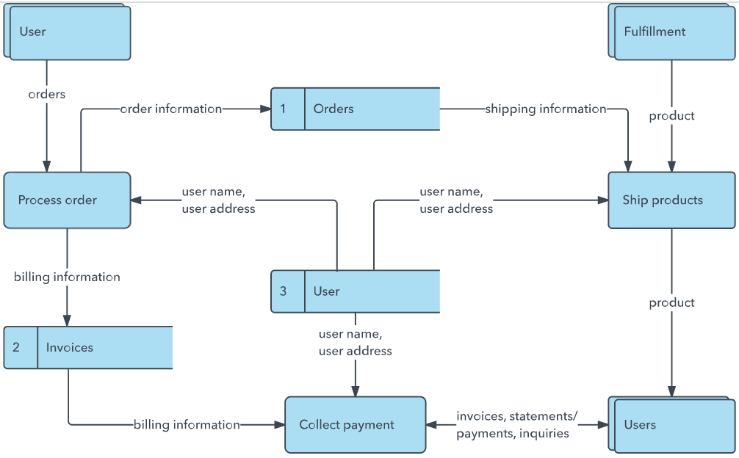

**User Stories**

Use the below template to list all the user stories for the product.

| **User Type** | **Functional Requirement (Epic)** | **User Story Number** | **User Story / Task** | **Acceptance Criteria** | **Priority** | **Release** |
| --- | --- | --- | --- | --- | --- | --- |
| Customer (Mobile user) | Registration | USN-1 | As a user, I can register for the app by entering my email, password, and confirm it. | I can access my account/dashboard after registration. | High | Sprint-1 |
|  | Registration | USN-2 | As a user, I will receive a confirmation email after registering. | I receive an email and can click a link to confirm my account. | High | Sprint-1 |
|  | Registration | USN-3 | As a user, I can register using Facebook. | I can log in and access my dashboard using Facebook login. | Low | Sprint-2 |
|  | Registration | USN-4 | As a user, I can register using Gmail. | I can log in and access the dashboard using Gmail login. | Medium | Sprint-1 |
|  | Login | USN-5 | As a user, I can log in with my email and password. | I can successfully log in and view my dashboard. | High | Sprint-1 |